X-Intel
Software Requirements Specification

Prepared for INT252
Continuous Assessment 3
Autumn 2024

Submitted by:
Name: Rajesh Nahak
Registration number: 12216196
Roll No.: 9
Section: K22CG

Submitted to:
Dr. Karthick Panneerselvam
Uid: 27291



LOVELY PROFESSIONAL UNIVERSITY
JALANDHAR, PUNJAB

Acknowledgement

I respect and thank our int252 teacher Dr. Karthick Panneerselvam for providing me an opportunity to do the project work and giving us all support and guidance which made me complete my project.
I would also like to thank my parents and friends for constantly encouraging me during this project, which I could not have completed without their support and continuous encouragement.

Table of Contents

Revision History Error! Bookmark not defined.
1. Introduction 1
1.1 Purpose 1
1.2 Scope 1
1.3 Definitions, Acronyms, and Abbreviations 2
1.4 References 2
1.5 Overview 2
2. General Description 3
2.1 Product Perspective 3
2.2 Product Functions 4
2.3 User Characteristics 4
2.4 General Constraints 5
2.5 Assumptions and Dependencies 5
3. Specific Requirements 6
3.1 External Interface Requirements 6
3.1.1 User Interfaces 6
3.1.2 Hardware Interfaces 6
3.1.3 Software Interfaces 6
3.1.4 Communications Interfaces 6
3.2 Functional Requirements 7
3.2.1 Image Upload and Processing 7
3.2.2 Disease Prediction and Symptom Suggestion 7

3.5 Non-Functional Requirements 8
3.5.1 Performance 8
3.5.2 Reliability 8
3.5.3 Availability 8
3.5.4 Security 8
3.5.5 Maintainability 8
3.5.6 Portability 8
3.7 Design Constraints 8
3.9 Other Requirements 8
4. Analysis Models 8
4.1 Data Flow Diagrams (DFD) 9
5.Github link……………………………………………………………………………………………………15
A. Appendices 16
A.1 Appendix 1
A.2 Appendix 2

Introduction

The Software Requirements Specification (SRS) document for the AI Radiology System outlines the functional and non-functional requirements needed to design and implement this software. This SRS is intended to serve as a comprehensive resource for developers, system architects, and stakeholders to understand the system's design objectives, expected functionality, and constraints. The document will provide detailed requirements that software engineers can follow to ensure that the final product aligns with its intended purpose: enabling efficient and accurate disease detection from X-ray images.

  - Purpose

The purpose of this SRS document is to detail the requirements for the AI Radiology System, a software product designed to assist radiologists and healthcare professionals in diagnosing diseases from X-ray images. This document is intended for the development and testing teams, system architects, stakeholders, and end-users involved in the design, implementation, and use of the system. By providing clear specifications, this SRS aims to guide the entire software development life cycle to achieve an efficient, accurate, and user-friendly diagnostic tool for radiology.

1.2 Scope

The AI Radiology System, a machine learning-based software product, is designed to analyze uploaded X-ray images and predict possible diseases along with relevant symptoms based on the detected patterns. The scope of this software includes:

- Software Product Identification: The primary product, AI Radiology System, comprises:

  - Disease Detection Model: A pre-trained deep learning model for detecting diseases in X-ray images.
  - Symptom Suggestion Module: A system that provides a list of symptoms based on detected diseases to aid further diagnosis.
- Core Functionalities:

  - Disease Prediction: Upon uploading an X-ray image, the system uses machine learning algorithms to analyze the image and detect potential diseases.
  - Symptom Identification: Based on the identified disease, the system provides a list of associated symptoms to help radiologists assess the patient's condition.
  - User Interface: A simple, user-friendly interface for uploading X-ray images and viewing the analysis results.
- Benefits and Goals:

  - Efficiency: The system reduces diagnostic turnaround time by automating the initial analysis process.
  - Accuracy: By leveraging machine learning, the system provides reliable disease predictions to support radiologists in the diagnostic process.
  - Accessibility: This tool can assist healthcare providers in remote or underserved areas by providing preliminary diagnostic support.
  - Standardization: Provides consistent results and symptom suggestions to support diagnostic accuracy across different users and locations.

1.3 Definitions, Acronyms, and Abbreviations

This section defines terms, acronyms, and abbreviations used in this document to ensure a common understanding among readers.
- AI: Artificial Intelligence, the use of algorithms and data to mimic human intelligence.
- ML: Machine Learning, a subset of AI focused on developing systems that can learn from data.
- X-ray: A diagnostic imaging technique commonly used to view internal structures of the body.
- Radiology: The medical specialty that uses imaging techniques, such as X-rays, for diagnosing and treating diseases.
- SRS: Software Requirements Specification, a document outlining the functional and non-functional requirements for a software system.

1.4 References

The references section lists all documents that inform or support this SRS. These documents can include technical references, research articles, regulatory guidelines, and any related documents for the development of the AI Radiology System.
- IEEE Guide to Software Requirements Specification – IEEE Standard 830-1998, IEEE.
- Project Overview Document – “AI Radiology System: Project Overview”, August 2023.
- Disease Detection Model Documentation – “Disease Detection Model: Specifications and Training Procedures”, 2024.
- System Design Document – “AI Radiology System: System Design”, September 2023.
- Data Science in Radiology – “AI and Machine Learning in Radiology”, Academic Press, 2022.
These references are available from the software development team and relevant publishing organizations.

1.5 Overview

This SRS document is organized as follows:
- Introduction: Provides a high-level overview of the system, its purpose, scope, and intended audience, along with definitions, references, and an outline of the document’s structure.
- Overall Description: Details the general factors that influence the system requirements, including product perspective, functions, user characteristics, and constraints.
- Specific Requirements: Specifies detailed functional and non-functional requirements for the AI Radiology System.
- External Interface Requirements: Outlines the interfaces required to interact with other systems, devices, or software.
- System Features: Describes the core features and functionalities the software will provide.
- Non-functional Requirements: Defines the performance, security, usability, and other non-functional criteria the system must meet.
- Appendices and Glossary: Provides supporting information and definitions for technical terms used throughout the document.
This structure enables a logical flow of information, ensuring that all stakeholders can readily locate the information they need regarding the system’s requirements and functionality.

2 General Description

This section provides a broad overview of the AI Radiology System to give readers a comprehensive understanding of the factors influencing the requirements of the software. These descriptions do not list specific requirements but instead clarify the context in which the software will operate, summarizing the product's perspective, functions, user characteristics, constraints, and dependencies.

2.1 Product Perspective

The AI Radiology System is designed to work as an advanced tool for diagnostic support in radiology, specifically for analyzing X-ray images to identify potential diseases. This product functions independently but may integrate with other healthcare systems, including electronic health records (EHR) and radiology information systems (RIS). By creating a streamlined process for disease prediction, this software complements traditional radiology practices by providing a preliminary analysis of X-ray images, allowing radiologists to focus on more complex diagnostics and interpretation.

In comparison to other medical diagnostic software, the AI Radiology System incorporates machine learning models specifically trained on a large dataset of labeled X-ray images. This model predicts disease probabilities and provides associated symptom suggestions, enhancing the diagnostic process with evidence-based support. Additionally, the AI Radiology System aims to reduce diagnostic variability and improve diagnostic turnaround time. This software does not perform clinical decision-making but instead provides support to healthcare professionals who interpret the results based on the software's output. The system is intended for use in hospitals, clinics, and potentially in telemedicine setups to assist radiologists and healthcare professionals who do not specialize in radiology but require access to preliminary diagnostic information.

The product is designed with flexibility in mind, allowing for potential integration with future AI-based diagnostic tools or expansions to include other imaging modalities. However, it does not support direct treatment recommendations or patient management capabilities, limiting its scope strictly to diagnostic support based on X-ray analysis. Future enhancements may include integration with additional imaging types or real-time data feeds from EHR systems.

2.2 Product Functions
The AI Radiology System provides several key functions to support radiological diagnostics. First, it allows users to upload X-ray images via a user-friendly interface. The system then processes the image through a machine learning model trained to detect abnormalities indicative of diseases. After analyzing the image, the software outputs a list of potential diseases along with a probability score for each detected condition. This probability score is derived from the model’s analysis of visual features within the X-ray image that are associated with various diseases.

Following disease detection, the system provides a list of symptoms related to the identified diseases, which helps users correlate findings with clinical symptoms. This symptom suggestion function is designed to assist radiologists or clinicians by providing quick reference information, potentially enabling them to prioritize cases that may require urgent attention. Additionally, the system includes a reporting feature, allowing users to download or view diagnostic summaries for further clinical use or integration into the patient's health records
.
The AI Radiology System also has built-in error handling and diagnostic feedback. In cases where the system cannot confidently identify a disease, it notifies the user and suggests potential areas where manual review is necessary. This feedback loop is crucial for maintaining diagnostic accuracy and allowing healthcare providers to make well-informed decisions. Moreover, all functions are designed to comply with medical software standards, ensuring the system is safe and reliable for clinical use.

2.3 User Characteristics

The primary users of the AI Radiology System are healthcare professionals, including radiologists, general practitioners, and healthcare assistants. These users possess varying levels of expertise in interpreting medical imaging, with radiologists being highly trained specialists, while general practitioners may have limited radiology knowledge. Additionally, healthcare assistants or technicians might operate the system to upload images or generate reports without needing to interpret diagnostic information.

Most users are expected to have a basic understanding of medical terminology and diagnostic processes. Therefore, the system’s interface is designed to be intuitive and accessible, with clear options for uploading images, viewing results, and accessing help. Detailed explanations of technical terms and probability scores are provided to support non-specialist users, ensuring that all users, regardless of medical background, can use the system effectively. Furthermore, the software will include user support in the form of tooltips, guides, and potentially live support, especially for telemedicine contexts where remote clinicians may rely on the system for preliminary diagnostics.

Security and patient data privacy are paramount, as users are handling sensitive patient information. All users must log into the system, ensuring authorized access only. Training for the AI Radiology System may be provided to some users, particularly healthcare professionals who are not radiologists, to ensure proper system utilization and result interpretation. The software’s design considers these user characteristics to ensure the system is effective and secure in diverse medical settings.

2.4 General Constraints
The development and operation of the AI Radiology System are subject to several constraints. One major constraint is regulatory compliance, as medical diagnostic software must adhere to health industry standards such as HIPAA (Health Insurance Portability and Accountability Act) in the United States, GDPR (General Data Protection Regulation) in the European Union, and other local healthcare regulations. These regulations impose stringent requirements on data privacy, security, and patient confidentiality, mandating secure data handling and user authentication mechanisms in the system design.
Hardware and system requirements also impose constraints. The AI Radiology System requires high computational power to run image-processing algorithms, potentially necessitating dedicated GPU support for effective image analysis. Hospitals and clinics that implement the system must meet these hardware specifications to ensure optimal performance. Additionally, network connectivity is essential, especially if the system is deployed in a cloud environment where users must upload images and access results online. This dependency on reliable internet access may limit the system’s effectiveness in low-resource settings.

Finally, the machine learning model requires periodic updates to maintain accuracy. As new data becomes available, retraining is necessary to improve disease detection capabilities and to ensure that the software remains relevant with emerging diagnostic needs. This ongoing update requirement introduces a constraint on system maintenance, as developers need to provide timely updates to improve and expand the system’s diagnostic range.

2.5 Assumptions and Dependencies
The AI Radiology System relies on certain assumptions and dependencies for successful operation. First, it assumes the availability of a sufficient quantity of labeled X-ray images to effectively train the machine learning model. A lack of diverse, high-quality data could impact the model's accuracy, especially for rare diseases. The system also assumes that the necessary machine learning frameworks, libraries, and image processing tools will remain compatible with the development environment, as any significant changes in these tools might necessitate redevelopment or adaptation.

A second assumption is that the healthcare facilities using the AI Radiology System have access to compatible hardware, such as systems with GPU capabilities to support efficient image processing. The software depends on high-performance hardware to analyze images swiftly; without adequate hardware, there may be delays in diagnosis.

In terms of software dependencies, the AI Radiology System relies on cloud storage and computational infrastructure for data management and model deployment. Therefore, the availability and reliability of cloud services are critical. Another dependency is regulatory alignment with local laws on data storage and processing, particularly if the system is used across multiple regions with varying legal standards. Any changes in healthcare regulations may impact the system’s operations, requiring developers to modify software functions or security protocols accordingly.

3.Specific Requirements

This section provides the detailed requirements necessary to design, implement, and test the AI Radiology System. These requirements are defined to ensure that each aspect of the software aligns with customer expectations while also serving as a guideline for the development and testing teams. Each requirement is designed to be correct, traceable, unambiguous, verifiable, prioritized, complete, consistent, and uniquely identifiable.

3.1 External Interface Requirements

3.1.1 User Interfaces
The system’s user interface (UI) is designed to provide a clear and intuitive experience for medical professionals, with components to allow users to upload X-ray images, view diagnostic results, and access help resources. The UI will be accessible via web browsers and mobile platforms, optimized for both touchscreen and standard mouse/keyboard interfaces. Key elements include:
- Upload Interface: A straightforward drag-and-drop or browse functionality for X-ray image uploads.
- Results Display: A clear summary of findings with probability scores, symptoms, and downloadable reports.
- Help/Support Access: Tooltips, FAQs, and contact options for technical support.

3.1.2 Hardware Interfaces
The AI Radiology System requires a computing device with adequate storage and processing capabilities. For on-site deployments, hardware with GPU support may be required to optimize image analysis performance. The system must also integrate with medical imaging devices (e.g., X-ray machines) and the hospital network for seamless data transfer.

3.1.3 Software Interfaces
The system integrates with hospital EHR systems, RIS, and potentially with cloud storage for secure data handling. The AI model relies on machine learning libraries and frameworks like TensorFlow or PyTorch, and is compatible with cloud services such as AWS or Azure. Additionally, the system interfaces with standard security and compliance software to ensure patient data privacy.

3.1.4 Communications Interfaces
The system requires a reliable internet connection to support data transfer for image uploads, cloud-based processing, and report generation. It uses secure protocols (e.g., HTTPS, SSL/TLS) to safeguard data integrity and confidentiality. The system should also support VPN access for remote usage in telemedicine.

3.2 Functional Requirements
This section describes the specific features and functions of the AI Radiology System.

3.2.1 Image Upload and Processing

3.2.1.1 Introduction
The image upload function allows users to add X-ray images for diagnostic analysis.

3.2.1.2 Inputs
Users upload image files, either in DICOM or JPEG formats, containing the relevant X-ray data.

3.2.1.3 Processing
The system pre-processes the image to enhance clarity and remove artifacts, then runs it through a trained machine learning model for disease prediction.

3.2.1.4 Outputs
The output includes a probability score for each detected disease, along with a list of possible symptoms associated with the disease. The results are displayed and available for download.

3.2.1.5 Error Handling
If the file format is incompatible or the image resolution is insufficient, the system will display an error message and prompt the user to re-upload an acceptable file.

3.2.2 Disease Prediction and Symptom Suggestion

3.2.2.1 Introduction
This function performs disease analysis based on uploaded images, with predictions presented as probability scores and associated symptoms.

3.2.2.2 Inputs
The pre-processed image is input to the disease detection model.

3.2.2.3 Processing
The machine learning model analyzes the image, extracting features indicative of disease, and generates probability scores for possible conditions.

3.2.2.4 Outputs
A list of detected diseases with probability scores and symptom information for each condition.

3.2.2.5 Error Handling
If the model cannot provide confident predictions (below a set threshold), a message will indicate the need for manual review.

3.5 Non-Functional Requirements
These requirements ensure the overall quality of the system and define measurable expectations.

3.5.1 Performance
The system must process 95% of X-ray images within 30 seconds for a seamless user experience. Image upload and result retrieval should occur without significant lag, assuming standard internet bandwidth.

3.5.2 Reliability
System uptime should exceed 99.9% to ensure consistent availability. Error rates in image processing should remain below 0.1% for trained disease classes.

3.5.3 Availability
The system should be accessible 24/7, with planned maintenance downtime not exceeding 2 hours per month.

3.5.4 Security
Data encryption is mandatory for all data transfers. User authentication and role-based access control must be implemented, with secure login mechanisms to prevent unauthorized access. All patient information must remain confidential, adhering to relevant healthcare regulations.

3.5.5 Maintainability
The system should be modular to facilitate updates and model retraining. It should allow patching and upgrading without requiring full shutdowns, and maintenance documentation should be readily available.

3.5.6 Portability
The software must run on standard server configurations and cloud environments like AWS and Azure, and it should be compatible with both Windows and Linux servers for flexible deployment.

3.7 Design Constraints
The system design is constrained by healthcare standards (HIPAA, GDPR) and must comply with regulations on data privacy, security, and record-keeping. Hardware limitations also constrain the system to devices capable of GPU-based image processing. The machine learning frameworks used must remain compatible with the system environment, and regular model updates should not disrupt operations.

3.9 Other Requirements
Additional requirements include:
- Documentation: Comprehensive user and maintenance manuals must be provided.
- Localization: Language support for non-English speaking users to enhance accessibility.
- Customer Support: Live support channels for troubleshooting and answering user inquiries.

4. Analysis Models
The Analysis Models section provides an overview of the various models used to help define and refine the specific requirements of the AI Radiology System. Each model is designed to offer a different perspective on the system’s functionality, behavior, and data flow. These models help clarify requirements, improve system understanding, and serve as a bridge between high-level requirements and the detailed design phase. Each model is traceable to the SRS requirements, ensuring alignment and consistency.

4.1 Data Flow Diagrams (DFD)

4.1.1 DFD Level 0 (Context Diagram)

The DFD Level 0, also known as the Context Diagram, provides a high-level view of the entire AI Radiology System. It outlines the system’s interaction with external entities like the Patient, Radiologist, and the Central Database. In this context, the AI Radiology System is treated as a single process. Here’s a breakdown of its key components:

- External Entities:
  - Patient: Provides personal information and medical history for imaging and requests image analysis.
  - Radiologist: Requests analysis, reviews AI-generated results, and validates diagnoses.
  - Central Database: Stores patient records, analyzed images, and diagnostic reports for easy retrieval.

- Data Flow:
  - From Patient to System: Patient information, medical images, and analysis requests.
  - From System to Patient: Diagnostic reports and consultation results.
  - From Radiologist to System: Image analysis requests and diagnosis validation.
  - From System to Radiologist: AI-generated analysis results for review.
  - Database Interaction: The system retrieves patient records and stores diagnostic results in the central database.

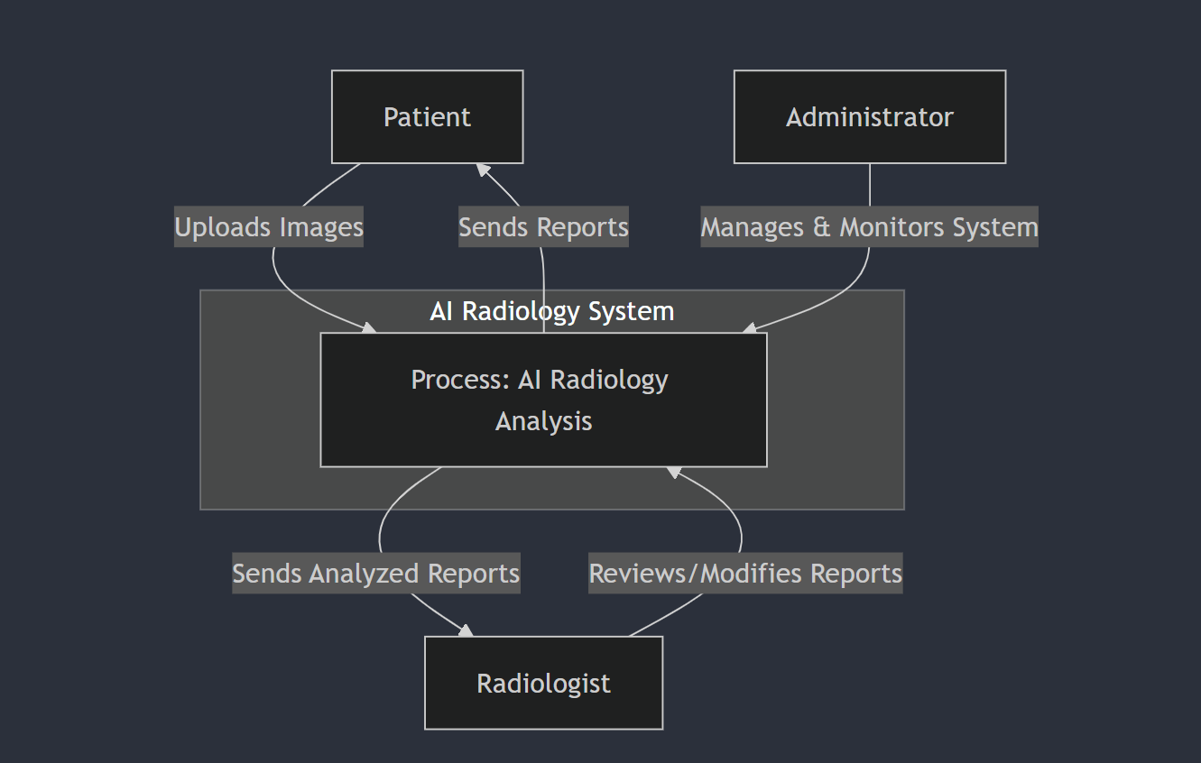

4.1.2. DFD Level 1

The DFD Level 1 further details the internal processes of the AI Radiology System. It breaks down the system into distinct functional areas and sub-processes. Here are the key components and flows represented at Level 1:

Processes:

Data Collection and Preprocessing: Collects patient information, retrieves relevant medical images, and prepares them for analysis by the AI model. This includes tasks like formatting and normalizing images.

Image Analysis: The AI model processes images to detect anomalies. This involves applying machine learning algorithms to identify patterns that indicate potential issues.

Diagnosis Generation: Uses analysis results to generate a preliminary diagnosis. This process outputs a diagnostic report which includes details on detected issues.

Report Generation: Compiles a report for the patient and radiologist, summarizing the diagnosis. This report is stored in the central database and sent to the relevant parties.

Database Management: Handles storage, retrieval, and updating of patient records, analysis data, and reports within the central database.

Data Flow:

From Patient to Data Collection: Sends patient information and image analysis requests.

From Data Collection to Image Analysis: Processes and sends preprocessed images.

From Image Analysis to Diagnosis Generation: Transmits detected patterns for diagnosis.

From Diagnosis Generation to Report Generation: Sends diagnostic information for report compilation.

Database Interaction: The system updates the database with new reports and retrieves patient information as needed.

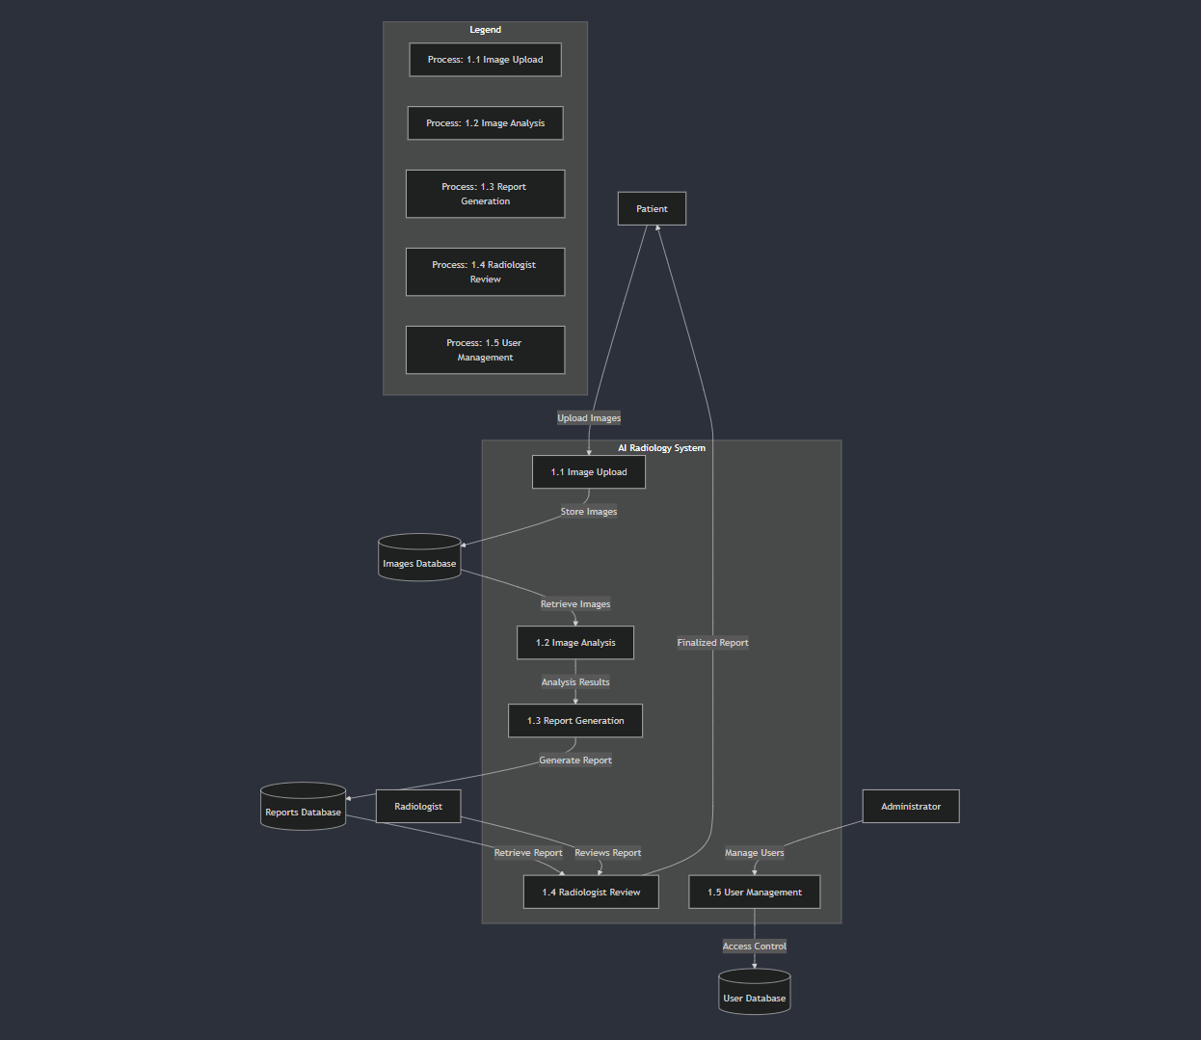
4.1.3. Entity-Relationship Diagram (ER Diagram)

The ER Diagram for the AI Radiology System illustrates the relationships between different entities in the database. Here are the key entities:
- Patient:
  - Attributes: patient_id, name, date_of_birth, contact_info
  - Relationship: Patients upload images and receive reports.
- Radiologist:
  - Attributes: radiologist_id, name, specialization, contact_info
  - Relationship: Radiologists review and validate reports generated by the system.
- Administrator:
  - Attributes: admin_id, name, role, contact_info
  - Relationship: Administrators manage accounts and oversee system operation.
- Image:
  - Attributes: image_id, patient_id, upload_date, image_type
  - Relationship: Images are uploaded by patients and analyzed by the system.
- Report:
  - Attributes: report_id, patient_id, radiologist_id, generated_date, status
  - Relationship: Generated based on analyzed images and reviewed by radiologists.
- Diagnosis:
  - Attributes: diagnosis_id, report_id, condition, severity, recommendations
  - Relationship: Contains detailed diagnostic information associated with each report.

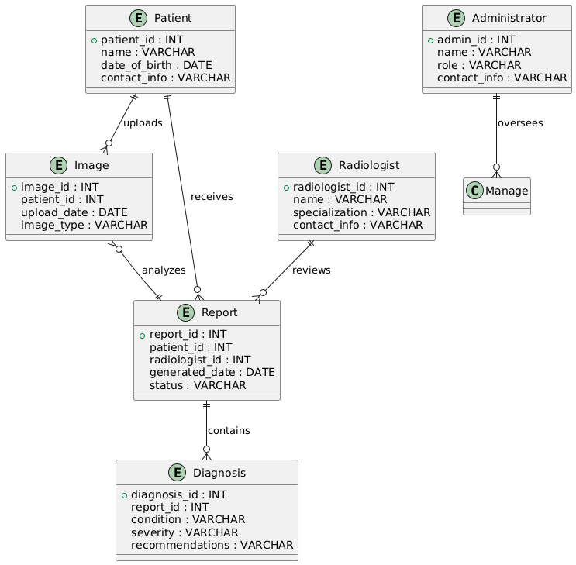

4.1.4. Use Case Diagram:-

The Use Case Diagram for the AI Radiology System describes the interactions between users and the system.

Here are the main use cases:

Patient Use Cases: Upload Image: Patients upload their medical images for analysis.

View Report: Patients view the diagnostic report generated and reviewed by radiologists. Radiologist

Use Cases: Review Report: Radiologists access the AI-generated report, review it, and make necessary adjustments.

Approve/Reject Report: Radiologists approve or reject the report based on its accuracy. Administrator

Use Cases: Manage Users: Administrators create and manage user accounts, including patients and radiologists.

Monitor System: Administrators oversee the overall system functionality and resolve issues.
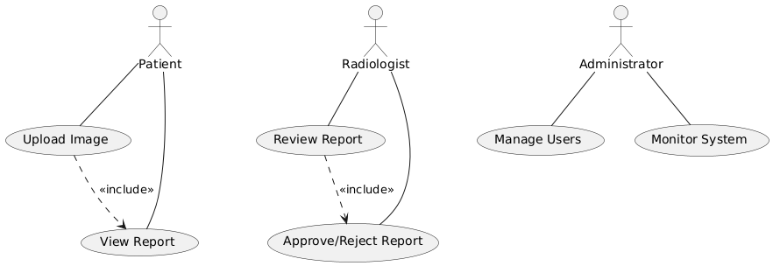

5.Github Link: -
https://github.com/rjsnhk/X-Intel

A. Appendices

Appendices provide supplementary information that supports the SRS document. This section is not part of the specific requirements but may contain useful background, conceptual information, and other reference materials for developers, stakeholders, or future teams involved in the project. The information within each appendix can help clarify design decisions, provide context, and enhance understanding of the overall project.
A.1 Appendix 1: Initial Concept Document
Appendix 1 could contain the initial concept document, which may include project goals, high-level objectives, and initial requirements discussed with stakeholders. This document outlines the motivation behind developing the AI Radiology System, key features, and anticipated challenges.
A.2 Appendix 2: Meeting Minutes and Stakeholder Feedback
Appendix 2 can include minutes from meetings with customers and stakeholders, summarizing discussions, decisions, and any agreed-upon changes in requirements. This record of interactions provides a transparent view of how requirements evolved, ensuring alignment with stakeholder expectations.

